**MINI PROJECT-2**

**(2021-22)**

**Vehicle Driving School Management System**

**PROJECT REPORT**



**GLA UNIVERSITY, MATHURA (UP)**

**Institute of Engineering & Technology**

**Department of Computer Engineering & Applications**

**Submitted By: Supervised By:**

Himanshi Agrawal Mr. Akash Choudhary

(181500267) (Technical Trainer)

Pranav Tomar

(181500475)

**ACKNOWLEDGEMENT**

We extend our deepest appreciation to our esteemed guide, Mr. Akash Chaudhary for providing me with the possibility to complete this project with the right guidance and advice.

Special gratitude we give to our respected head of the division Mr. Anand Singh Jalal, for allowing us to use the facilities available and also help us to coordinate our project.

Furthermore, we would also like to acknowledge with much appreciation the crucial role of faculty members on this occasion.

Last but not least, we would like to thank friends who helped us to assemble the parts and gave a suggestion about the project.

.

Himanshi Agrawal

(181500267)

Pranav Tomar

(181500475**)**

**Abstract**

With the rapid development of informational construction, higher request is needed by the management of drive-training enterprise. Driving-training school’s effective management can reduce the waste of human power and wealth very much, and ensure driving-training school’s information resource to be utilized effectively. As the share of human power and information becomes deeper and weeper, the management and share of driving-training school’s manager, vehicle and student become more and more important. Present management method’ key issues exist as follows. Enrollment, health examination and graduation information of drive-training school students are operated artificially, which is not only with low efficiency but also make mistakes often with many students, vehicle and coaches, distribute of student to coach and coach to vehicle is made artificially. In this way, resource can’t be assigned reasonably and used effectively, which are clumsy human usage, unclear of administration responsibility and so on.

**Introduction**

With the rapid development of informational construction, higher request is needed by the management of drive-training enterprise. Driving-training school’s effective management can reduce the waste of human power and wealth very much, and driving-training school’s information resource can be utilized effectively. As the share of human power and information becomes deeper and weeper , the management and share of driving-training school’s manager, vehicle and student become more and more important.

**Purpose:-**

The purpose of developing Car Driving School Management System is to computerized the tradition way of taking Driving-training school’s. Another purpose for developing this application is to generate the report automatically.

**Scope:-**

**Car Driving School Management System** project is developed as a web application and it will work over web.

**Car Driving School Management System**

In this project we use PHP and Mysql database. It has two modules admin and user.

**Admin Module**

1. **Dashboard:** In this section admin can see all detail in brief like total number of users, Total number of subscribes users and total number of enquiry received.
2. **Packages:** In this section admin can manage packages(add and update).
3. **Applied Users:** In this section admin can view the detail of user who wants to take training and also update the history of payments.
4. **Subscribed Users:** In this section admin can view subscribed users.
5. **Enquiry:** In this section admin can read new enquiry(unread enquiry) and view read enquiry(read enquiry).
6. **Pages:** In this section admin can manage about us and contact us pages.
7. **Search:** In this section admin can search users with the help of his/her registration number.
8. **Reports:** In this section admin can view users detail in particular periods.

Admin can also update his profile, change password and recover password.

**User Module**

In CDSMS user not require to sign in

**Home Page:** User can subscribe with driving school, user can view driving schools services and also put enquiries.

**Apply Now:** User can apply for training.

**Enquiry:** User put any enquiries.

**Packages:** User views the recent packages which offer by driving school.

**About Us:** User sees the detail of driving school

**Contact Us:** User can contact with driving school.

**Requirement Specification**

**Hardware Configuration :**

**Client Side:**

|  |  |
| --- | --- |
| **RAM** | 512 MB |
|  |  |
| **Hard disk** | 10 GB |
|  |  |
| **Processor** | 1.0 GHz |
|  |  |

**Server side:**

|  |  |
| --- | --- |
| **RAM** | **1 GB** |
| **Hard disk** | **20 GB** |
| **Processor** | **2.0 GHz** |

**Software Requirement:**

**Client Side:**

|  |  |
| --- | --- |
| **Web Browser** | Google Chrome or any compatible browser |
| **Operating System** | Windows or any equivalent OS |

**Server Side:**

|  |  |
| --- | --- |
| **Web Server** | APACHE |
| **Server side Language** | PHP5.6 or above version |
| **Database Server** | MYSQL |
| **Web Browser** | Google Chrome or any compatible browser |
| **Operating System** | Windows or any equivalent OS |

**APACHE**

The Apache HTTP Server Project is an effort to develop and maintain an open-source HTTP server for modern operating systems including UNIX and Windows. The goal of this project is to provide a secure, efficient and extensible server that provides HTTP services in sync with the current HTTP standards.

The Apache HTTP Server ("httpd") was launched in 1995 and it has been the most popular web server on the Internet since April 1996. It has celebrated its 20th birthday as a project in February 2015.

**PHP**

* PHP stands for PHP: Hypertext Preprocessor.
* PHP is a server-side scripting language, like ASP.
* PHP scripts are executed on the server.
* PHP supports many databases (MYSQL, Informix, Oracle, Sybase, Solid, Generic ODBC, etc.).
* PHP is an open source software .
* PHP is free to download and use.

**MYSQL**

* MYSQL is a database server
* MYSQL is ideal for both small and large applications
* MYSQL supports standard SQL
* MYSQL compiles on a number of platforms
* MYSQL is free to download and use
* How to access MySQL: <http://localhost/phpmyadmin>

**Analysis and Design**

**Analysis:**

In present all work done on the paper. The whole details is stored in the registers. We can’t generate reports as per our requirements because its take more time to calculate the attendance.

**Disadvantage of present system:**

* **Not user friendly:** The present system not user friendly because data is not stored in structure and proper format.
* **Manual Control:** All report calculation is done manually so there is a chance of error.
* **Lots of paper work:** Attendance maintain in the register so lots of paper require storing attendance.
* **Time consuming**

**Design Introduction:**

Design is the first step in the development phase for any techniques and principles for the purpose of defining a device, a process or system in sufficient detail to permit its physical realization.

Once the software requirements have been analyzed and specified the software design involves three technical activities - design, coding, implementation and testing that are required to build and verify the software.

The design activities are of main importance in this phase, because in this activity, decisions ultimately affecting the success of the software implementation and its ease of maintenance are made. These decisions have the final bearing upon reliability and maintainability of the system. Design is the only way to accurately translate the customer’s requirements into finished software or a system.

Design is the place where quality is fostered in development. Software design is a process through which requirements are translated into a representation of software. Software design is conducted in two steps. Preliminary design is concerned with the transformation of requirements into data.

UML Diagrams:

Actor:  
 A coherent set of roles that users of use cases play when interacting with the use `cases.

Use case:

A description of sequence of actions, including variants, that a system performs that yields an observable result of value of an actor.

UML stands for Unified Modeling Language. UML is a language for specifying, visualizing and documenting the system. This is the step while developing any product after analysis. The goal from this is to produce a model of the entities involved in the project which later need to be built. The representation of the entities that are to be used in the product being developed need to be designed.

**USECASE DIAGRAMS:**

Use case diagrams model behavior within a system and helps the developers understand of what the user require. The stick man represents what’s called an actor.

Use case diagram can be useful for getting an overall view of the system and clarifying who can do and more importantly what they can’t do.

Use case diagram consists of use cases and actors and shows the interaction between the use case and actors.

* The purpose is to show the interactions between the use case and actor.
* To represent the system requirements from user’s perspective.
* An actor could be the end-user of the system or an external system.

**USECASE DIAGRAM:**

A Use case is a description of set of sequence of actions. Graphically it is rendered as an ellipse with solid line including only its name. Use case diagram is a behavioral diagram that shows a set of use cases and actors and their relationship. It is an association between the use cases and actors. An actor represents a real-world object. Primary Actor – Sender, Secondary Actor Receiver.

**User Use Case Diagram**

**User**

**Admin use case diagram**

**Class Diagram:**

A description of set of objects that share the same attributes operations, relationships, and semantics.

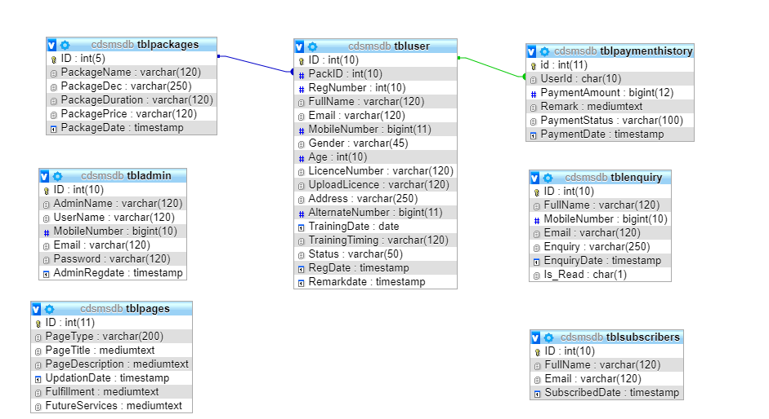

**ER Diagram:**

The Entity-Relationship (ER) model was originally proposed by Peter in 1976 [Chen76] as a way to unify the network and relational database views. Simply stated the ER model is a conceptual data model that views the real world as entities and relationships. A basic component of the model is the Entity-Relationship diagram which is used to visually represent data objects. Since Chen wrote his paper the model has been extended and today it is commonly used for database design for the database designer, the utility of the ER model is:

* It maps well to the relational model. The constructs used in the ER model can easily be transformed into relational tables.
* It is simple and easy to understand with a minimum of training. Therefore, the model can be used by the database designer to communicate the design to the end user.
* In addition, the model can be used as a design plan by the database developer to implement a data model in specific database management software.

## ER Notation

There is no standard for representing data objects in ER diagrams. Each modeling methodology uses its own notation. The original notation used by Chen is widely used in academics texts and journals but rarely seen in either CASE tools or publications by non-academics. Today, there are a number of notations used; among the more common are Bachman, crow's foot, and IDEFIX.

All notational styles represent entities as rectangular boxes and relationships as lines connecting boxes. Each style uses a special set of symbols to represent the cardinality of a connection. The notation used in this document is from Martin. The symbols used for the basic ER constructs are:

* **Entities** are represented by labeled rectangles. The label is the name of the entity. Entity names should be singular nouns.
* **Relationships** are represented by a solid line connecting two entities. The name of the relationship is written above the line. Relationship names should be verbs
* **Attributes**, when included, are listed inside the entity rectangle. Attributes which are identifiers are underlined. Attribute names should be singular nouns.
* **Cardinality** of many is represented by a line ending in a crow's foot. If the crow's foot is omitted, the cardinality is one.

**Existence** is represented by placing a circle or a perpendicular bar on the line. Mandatory existence is shown by the bar (looks like a 1) next to the entity for an instance is required. Optional existence is shown by placing a circle next to the entity that is optional.

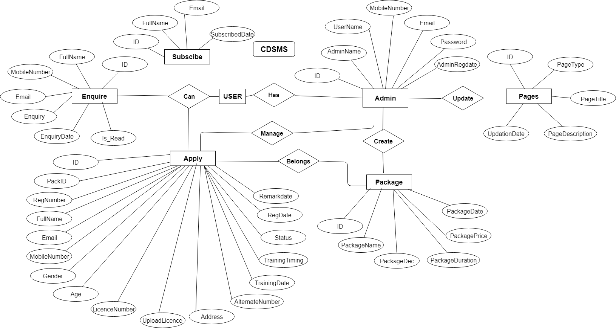

**Database Design**

The data in the system has to be stored and retrieved from database. Designing the database is part of system design. Data elements and data structures to be stored have been identified at analysis stage. They are structured and put together to design the data storage and retrieval system.

A database is a collection of interrelated data stored with minimum redundancy to serve many users quickly and efficiently. The general objective is to make database access easy, quick, inexpensive and flexible for the user. Relationships are established between the data items and unnecessary data items are removed. Normalization is done to get an internal consistency of data and to have minimum redundancy and maximum stability. This ensures minimizing data storage required, minimizing chances of data inconsistencies and optimizing for updates. The MS Access database has been chosen for developing the relevant databases.

**Car Driving School Management System (cdsmsdb) contains 7 MySQL tables :**

* tbladmin
* tblenquiry
* tblpackages
* tblpages
* tblpaymenthistory
* tblsubscribers
* tbluser

**tbladmin:** This tables stores admin login details.

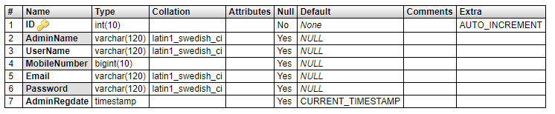

**tblenquiry :** This table stores user enquiry details.

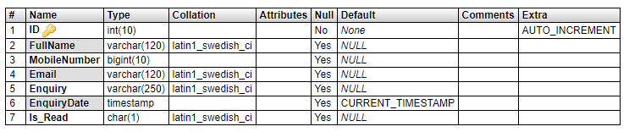

**Tblpackages:** This stores package details.

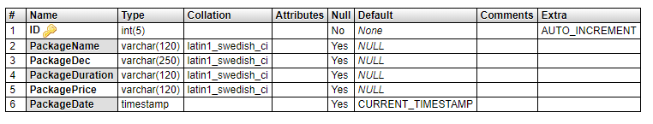

**tblpages:** This table stores page information.

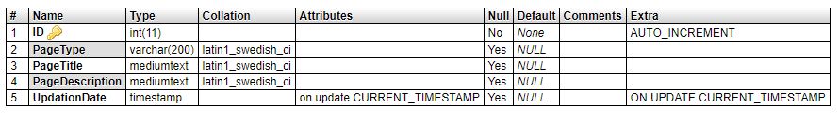

**tbluser:** This table store user application details.

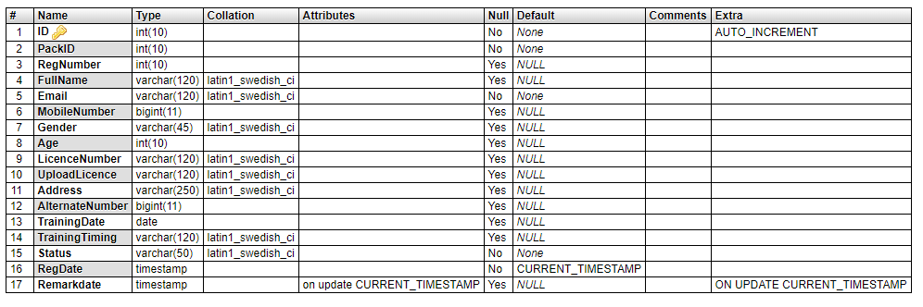

**tblpaymenthistory:** This table store payment history of user.

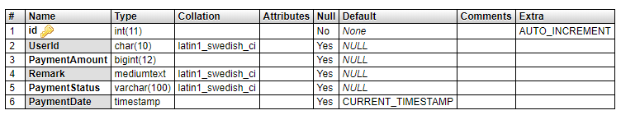

**tblsubscribers:** This table stored subscribers.

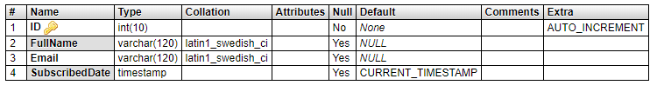

**DESIGN IMPLEMENTATION AND RESULTS**

Design implementation refers to the real live running of the designed program. This section consists of the program modules, showing what they do, and how the system can be deployed.

**Admin Module**

**Admin Login**

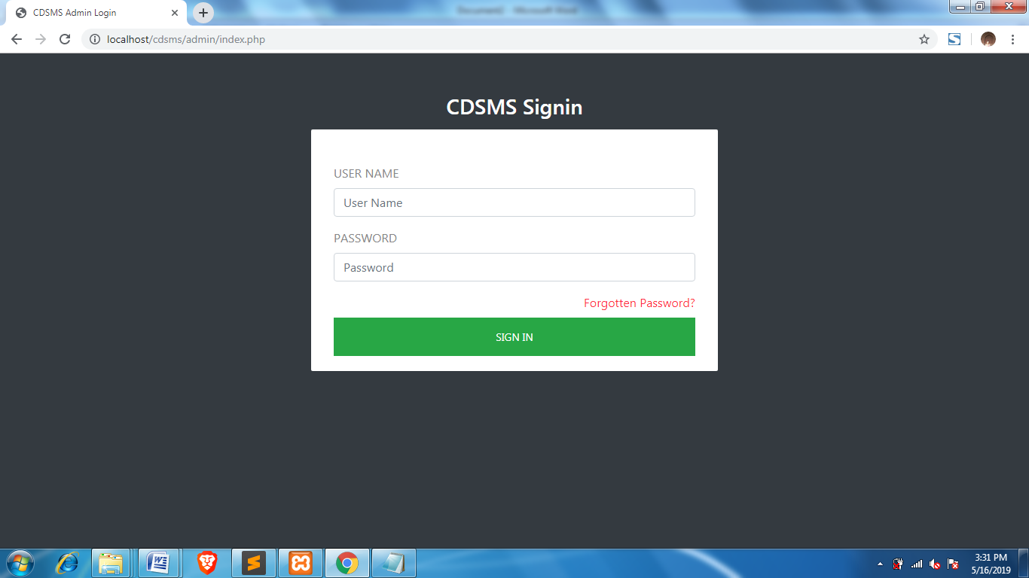

**Dashboard**

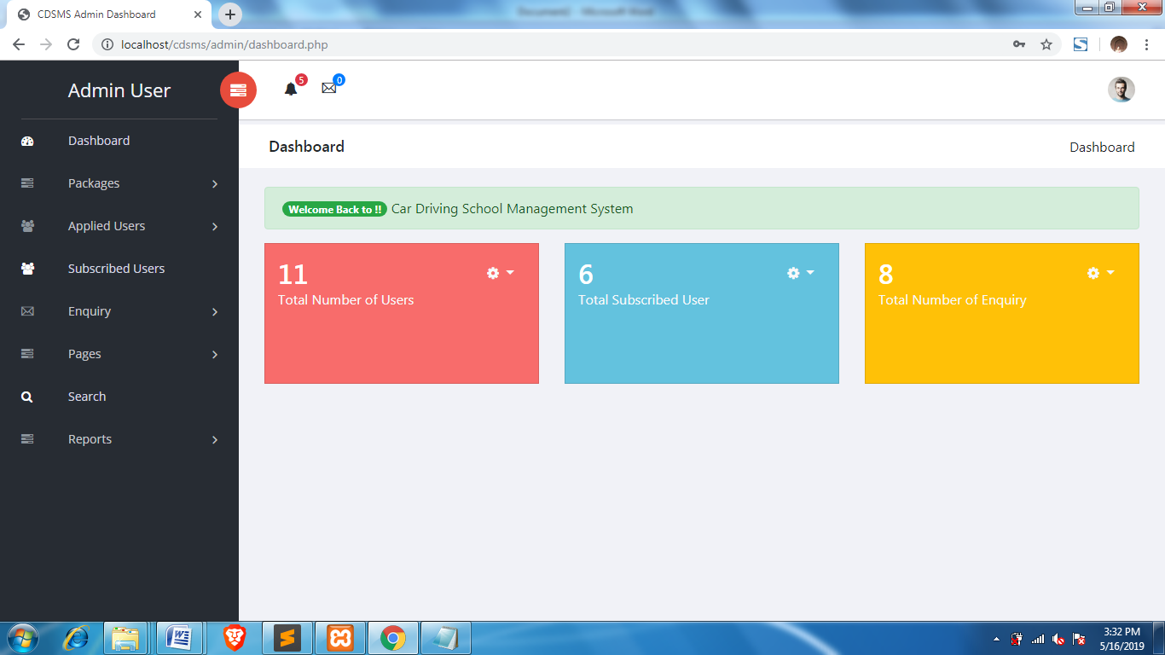

**Notification of application:**

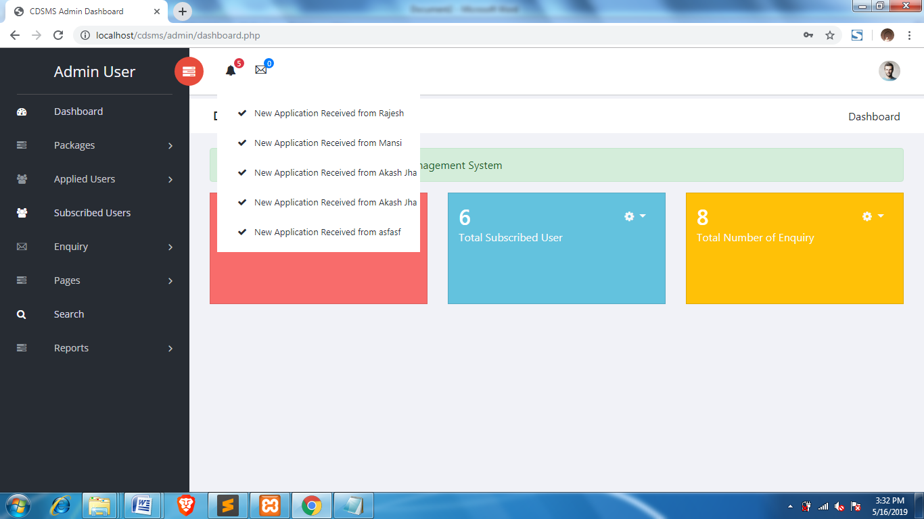

**Add Package**

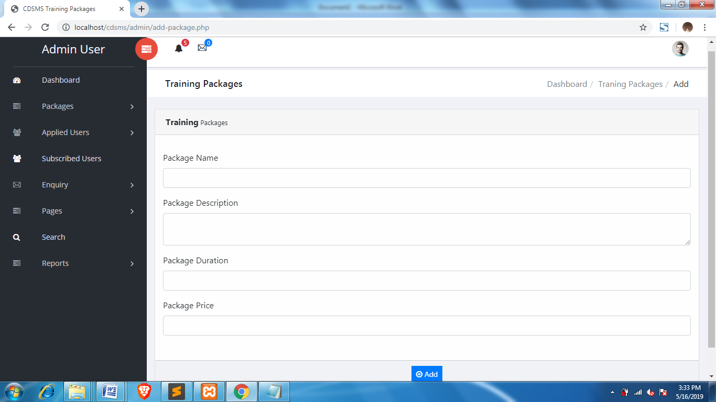

**Manage Package**

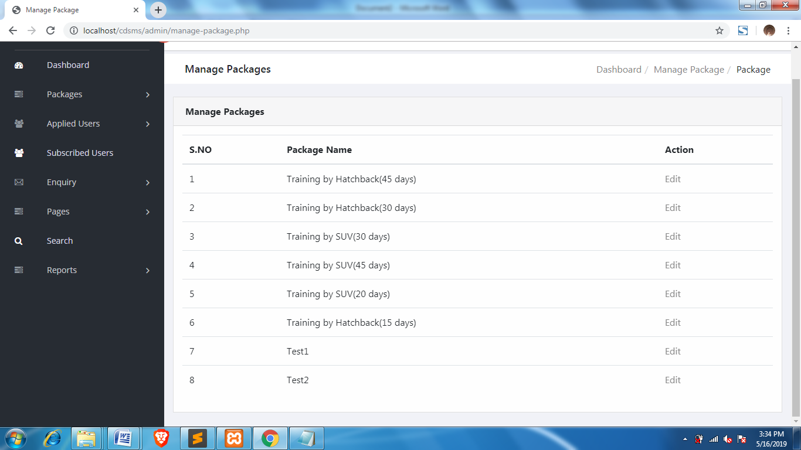

**Edit Package**

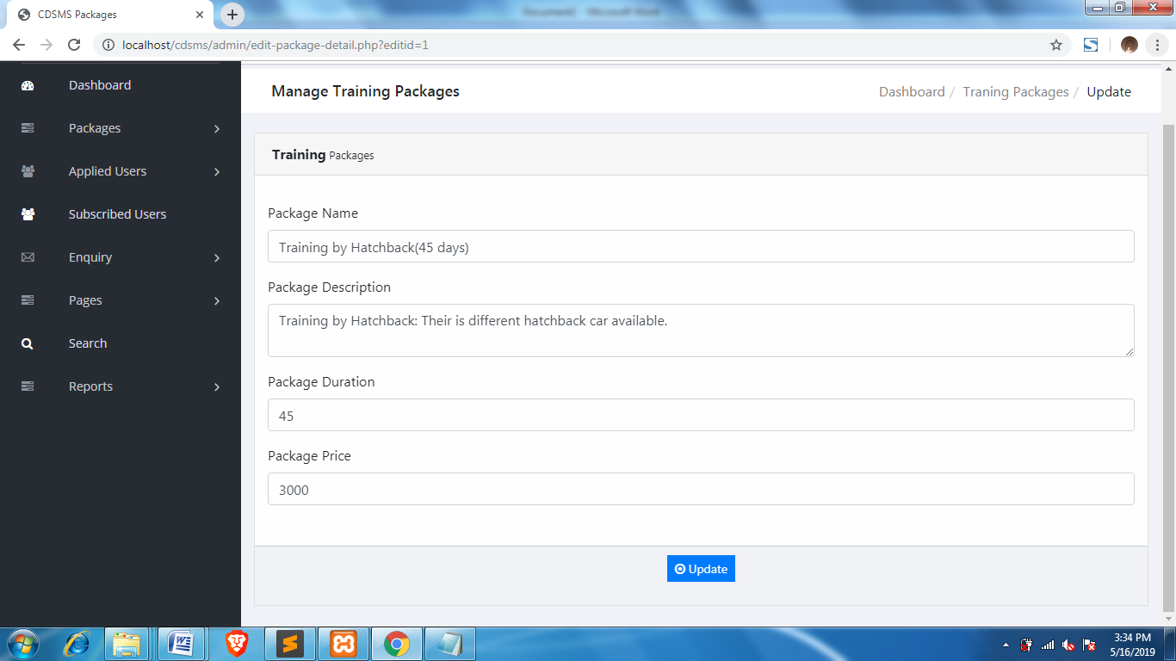

**New Users**

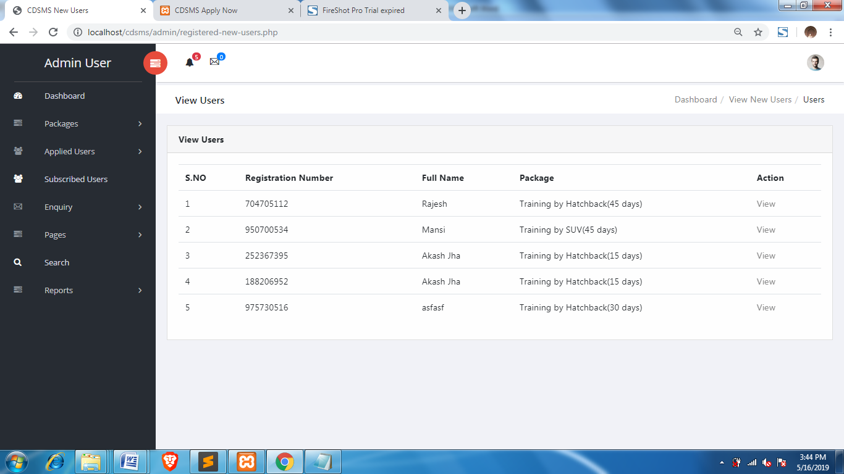

**User Details Page:**

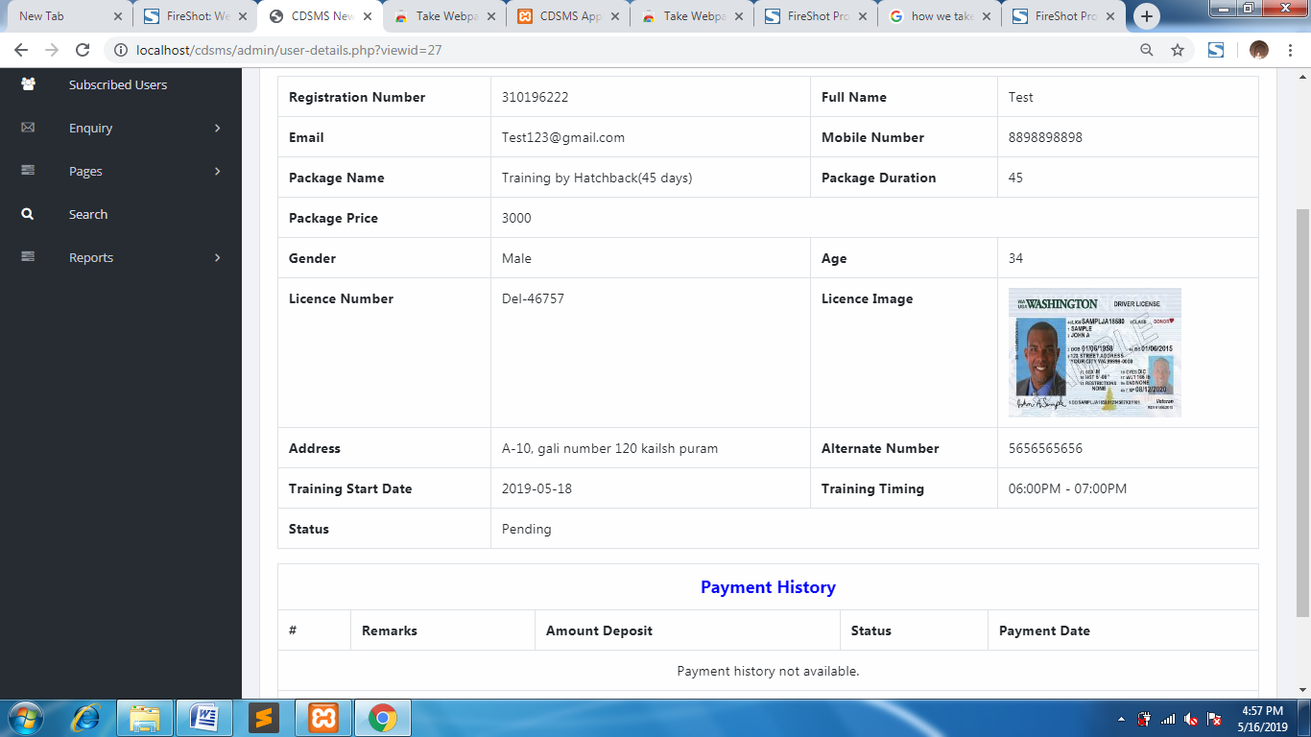

**Take Action**

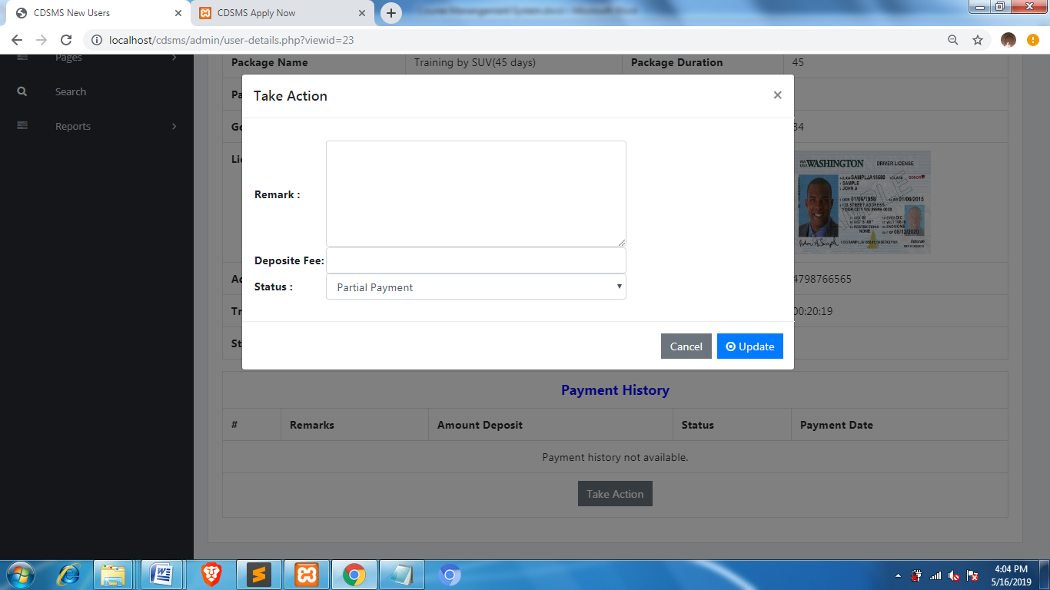

**Subscribed Users**

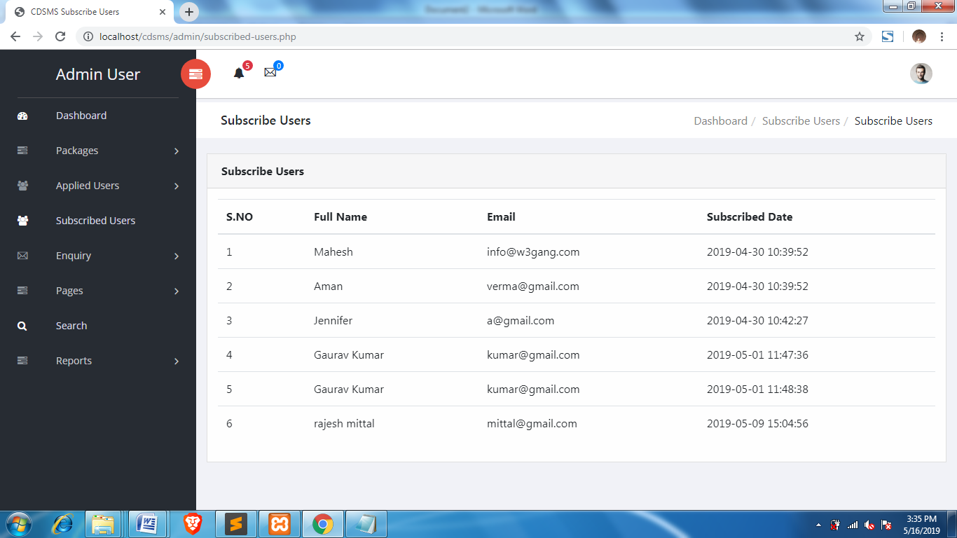

**Unread Enquiry**

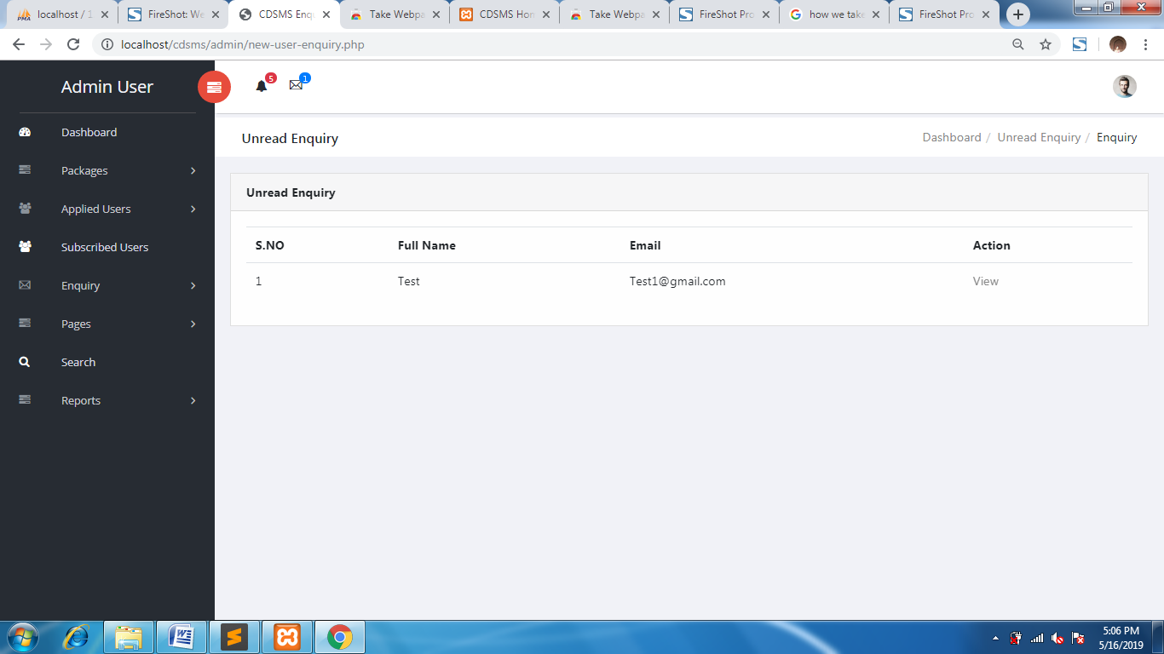

**Read Enquires**

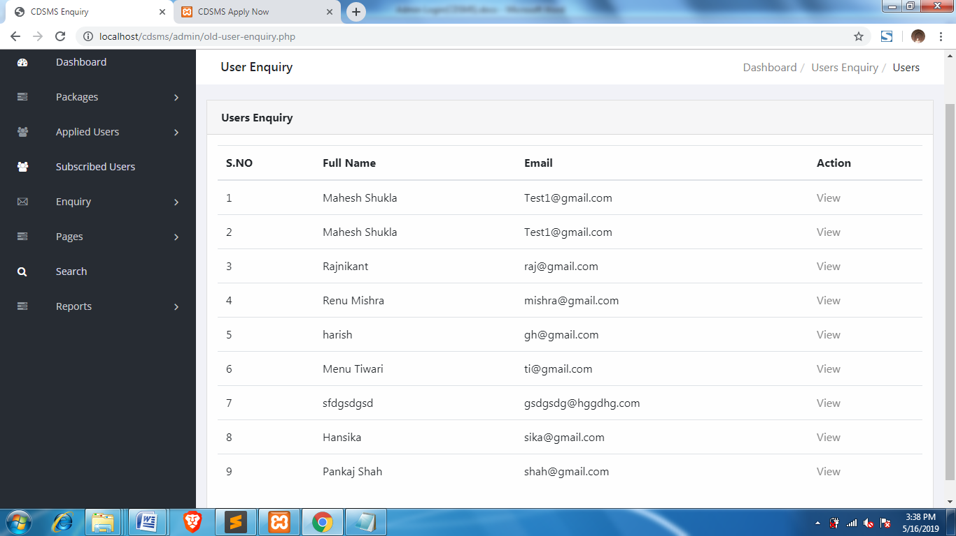

**View Enquiry**

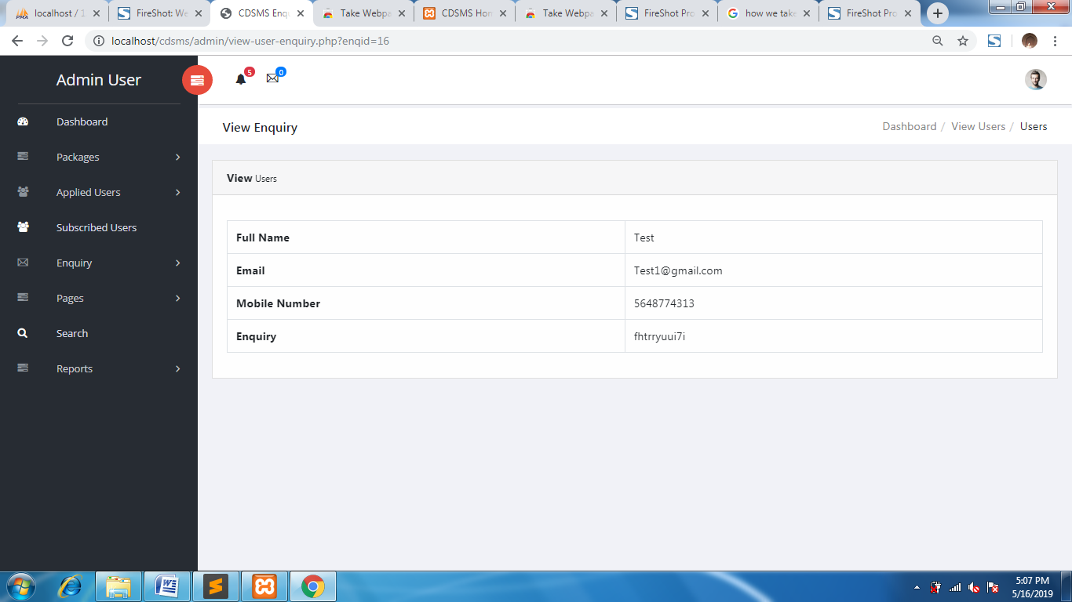

**About us**

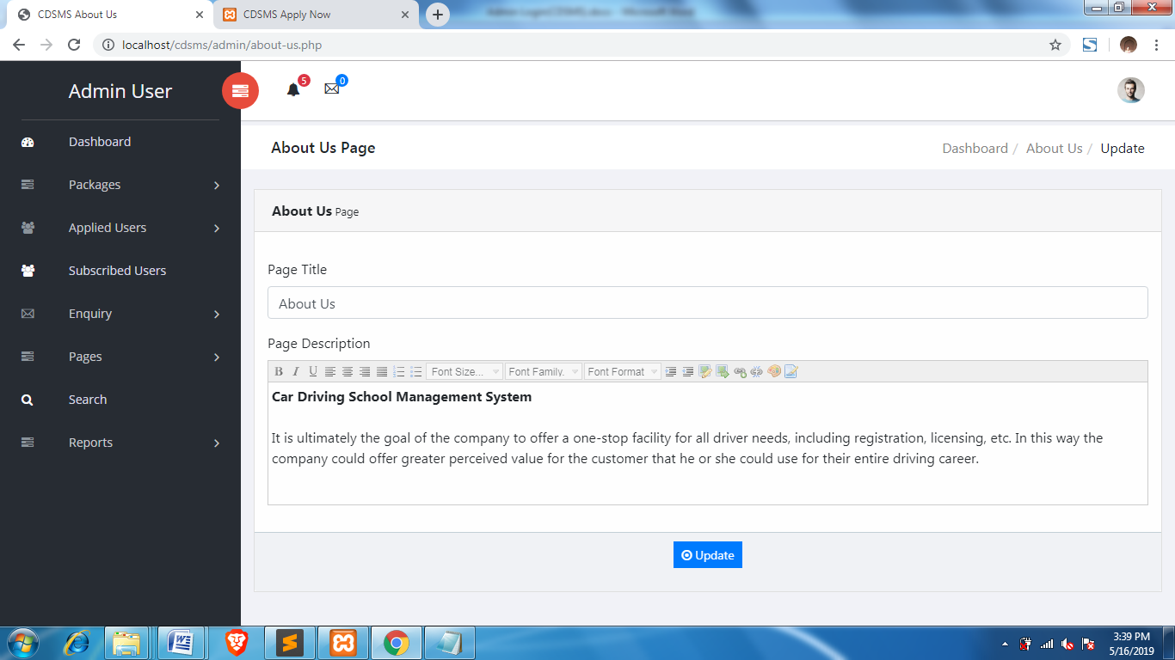

**Contact Us**

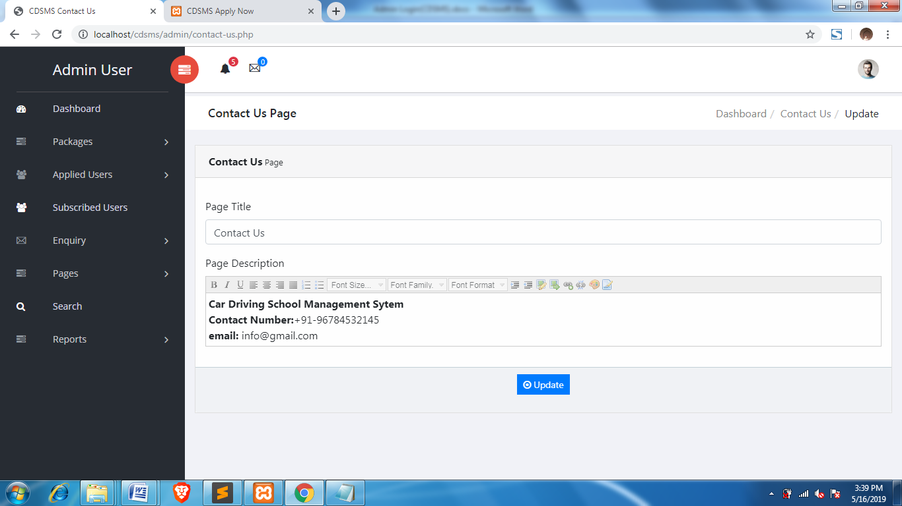

**Search Users**

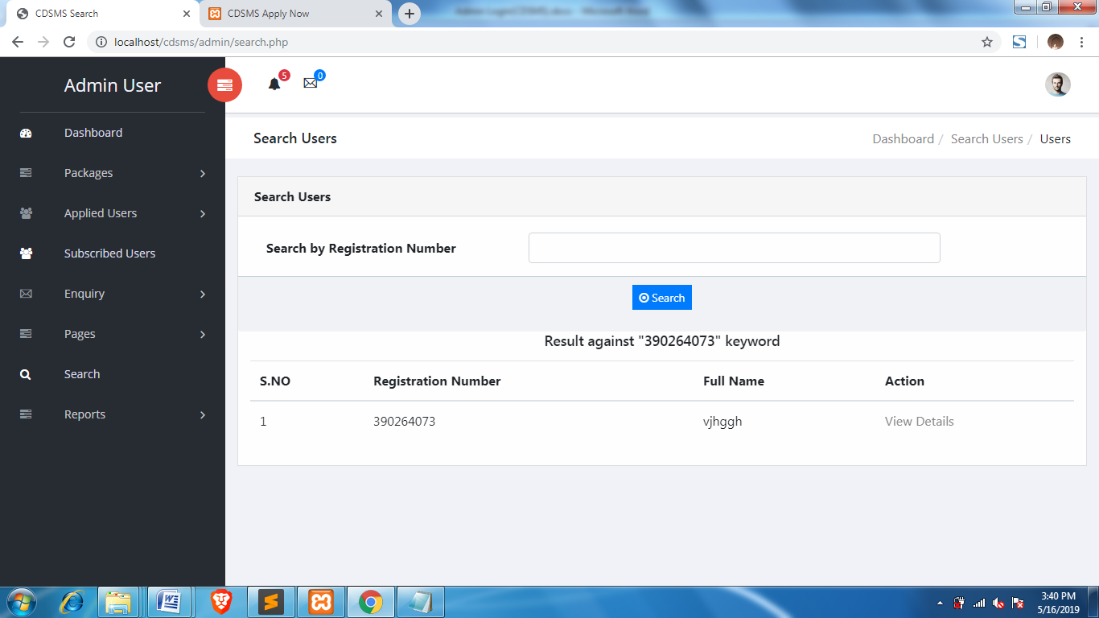

**Reports**

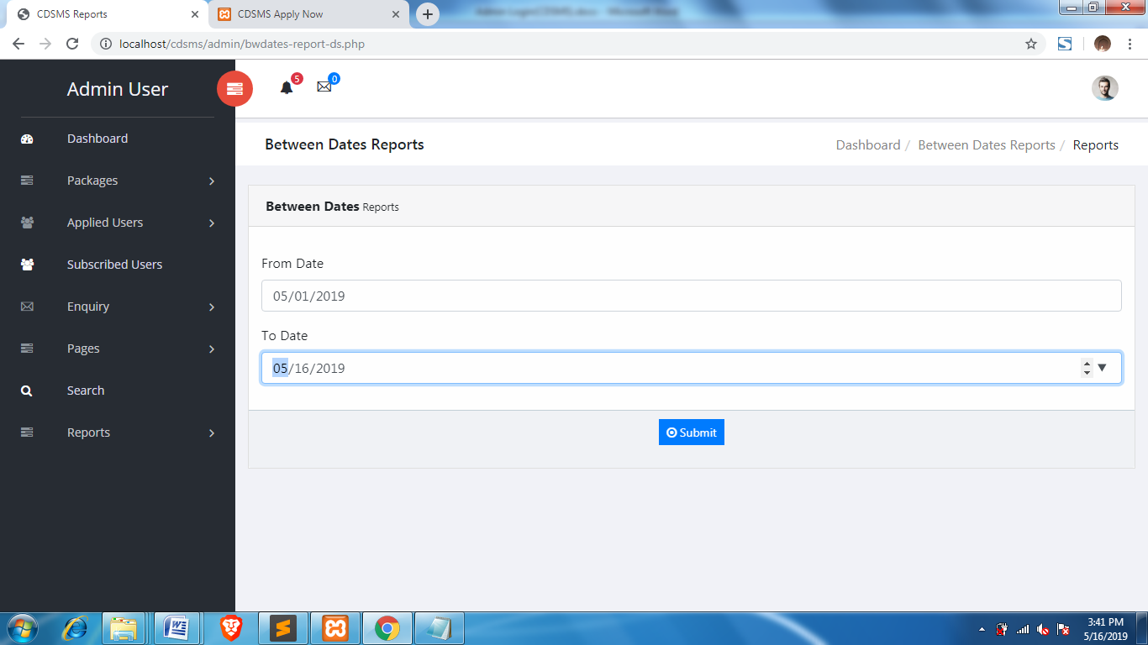

**Report Details**

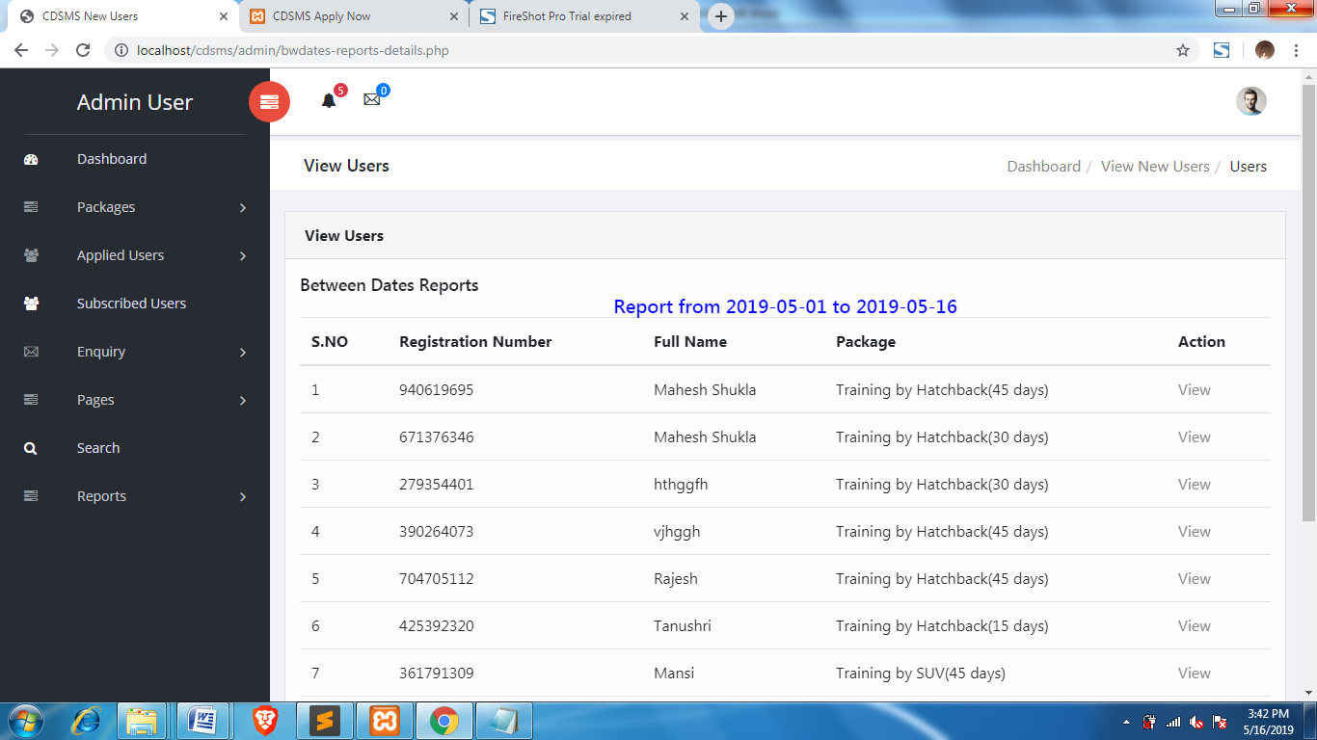

**Admin Profile**

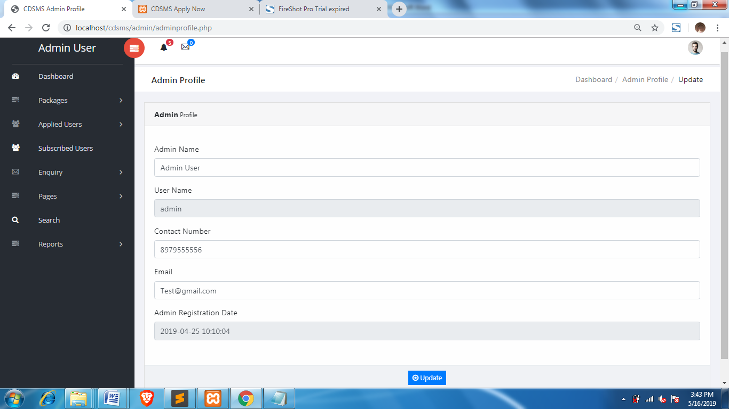

**Change Password**

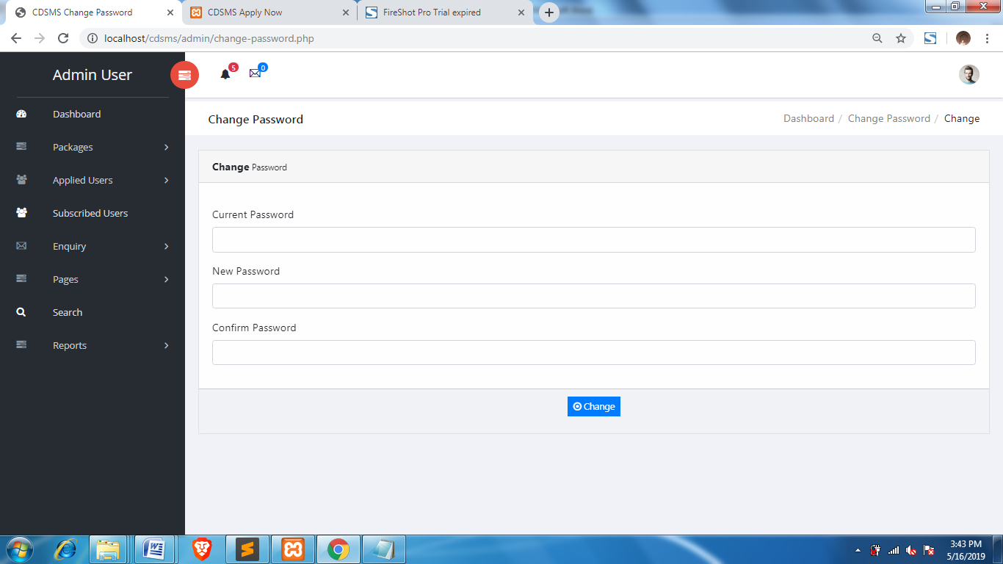

**Forgot Password**

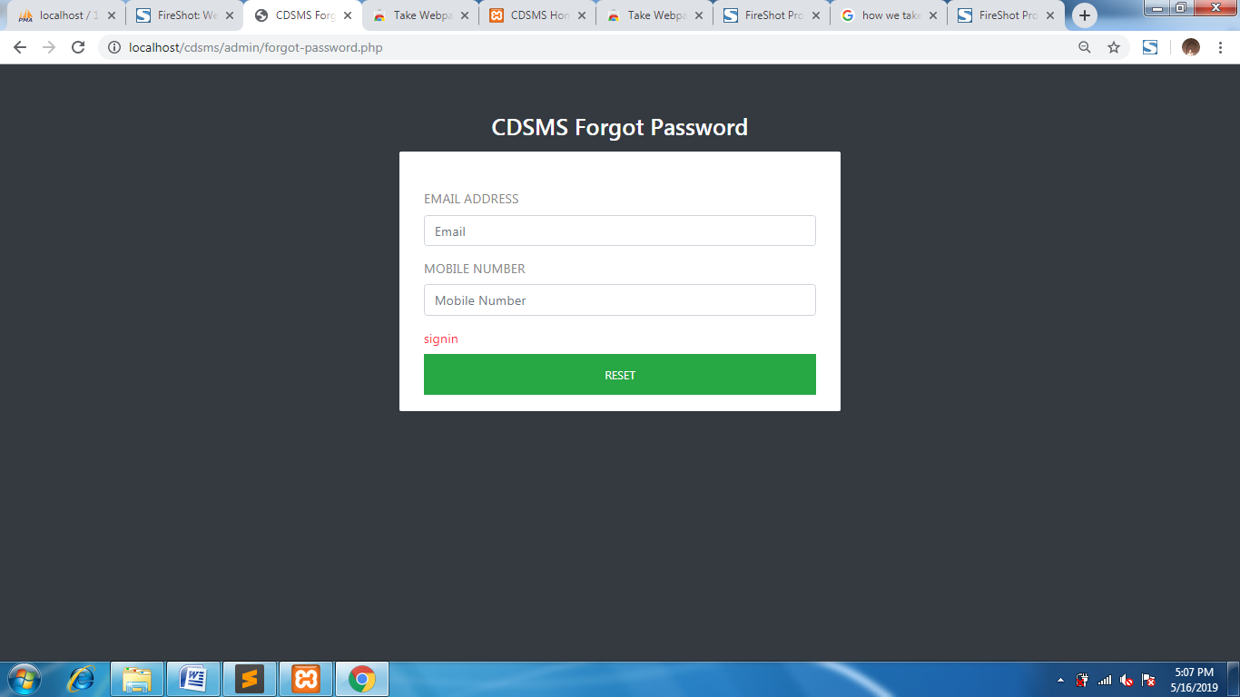

**Reset Password**

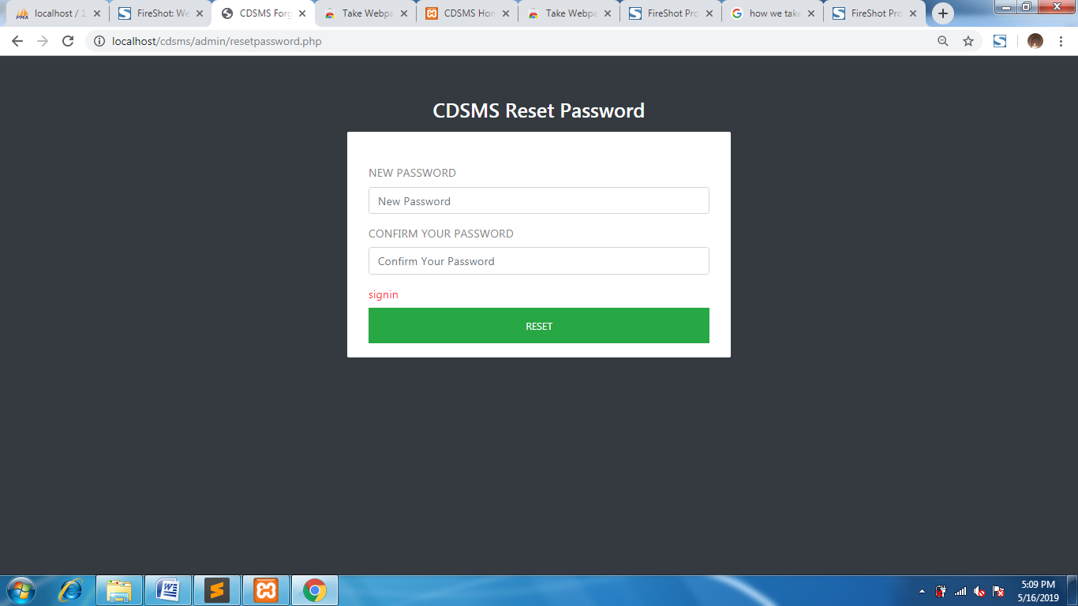

**USER Module**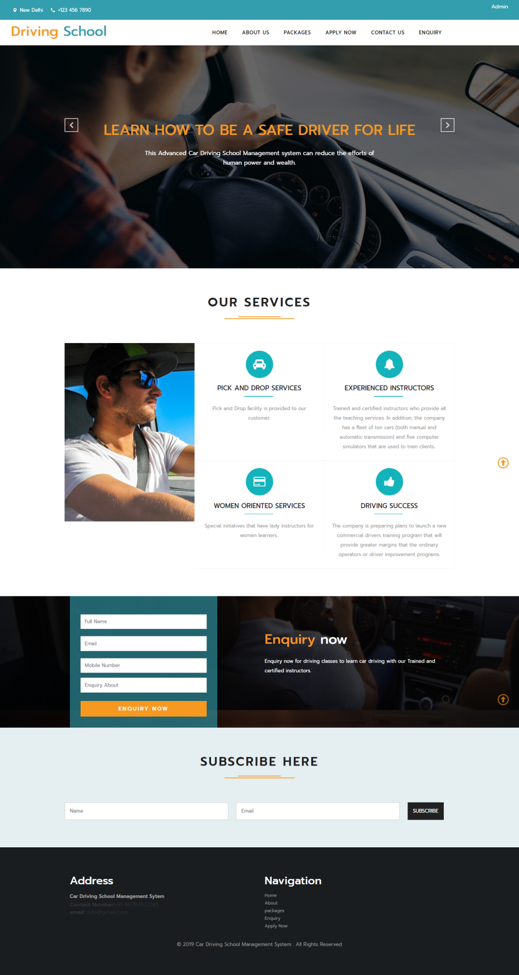

**About Us**

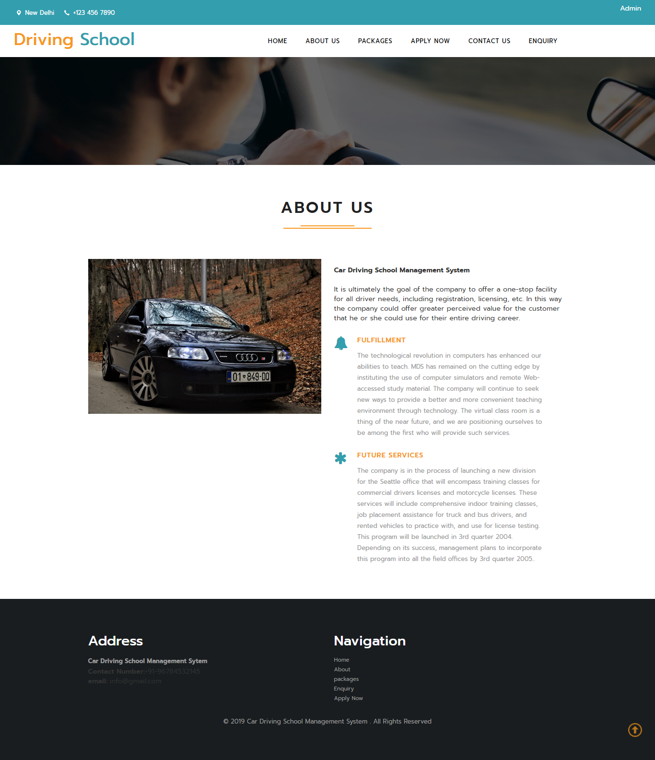

**Packages**

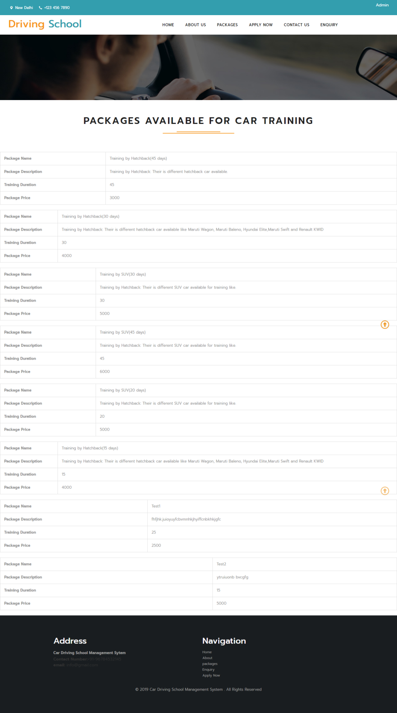

**Apply Now**

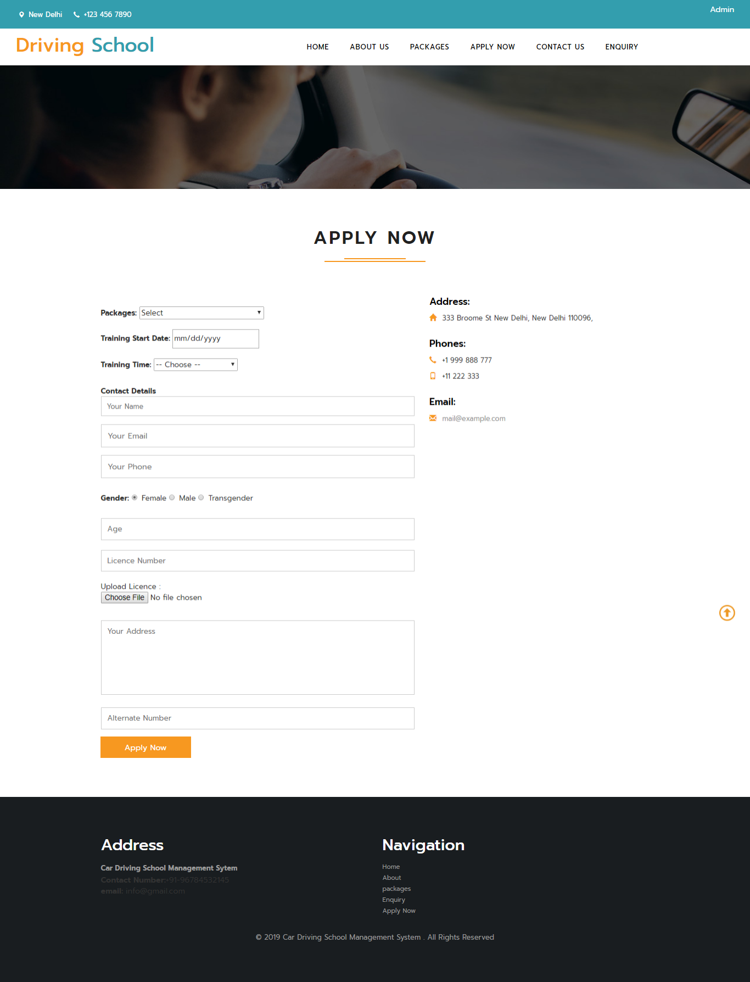

**Contact Us**

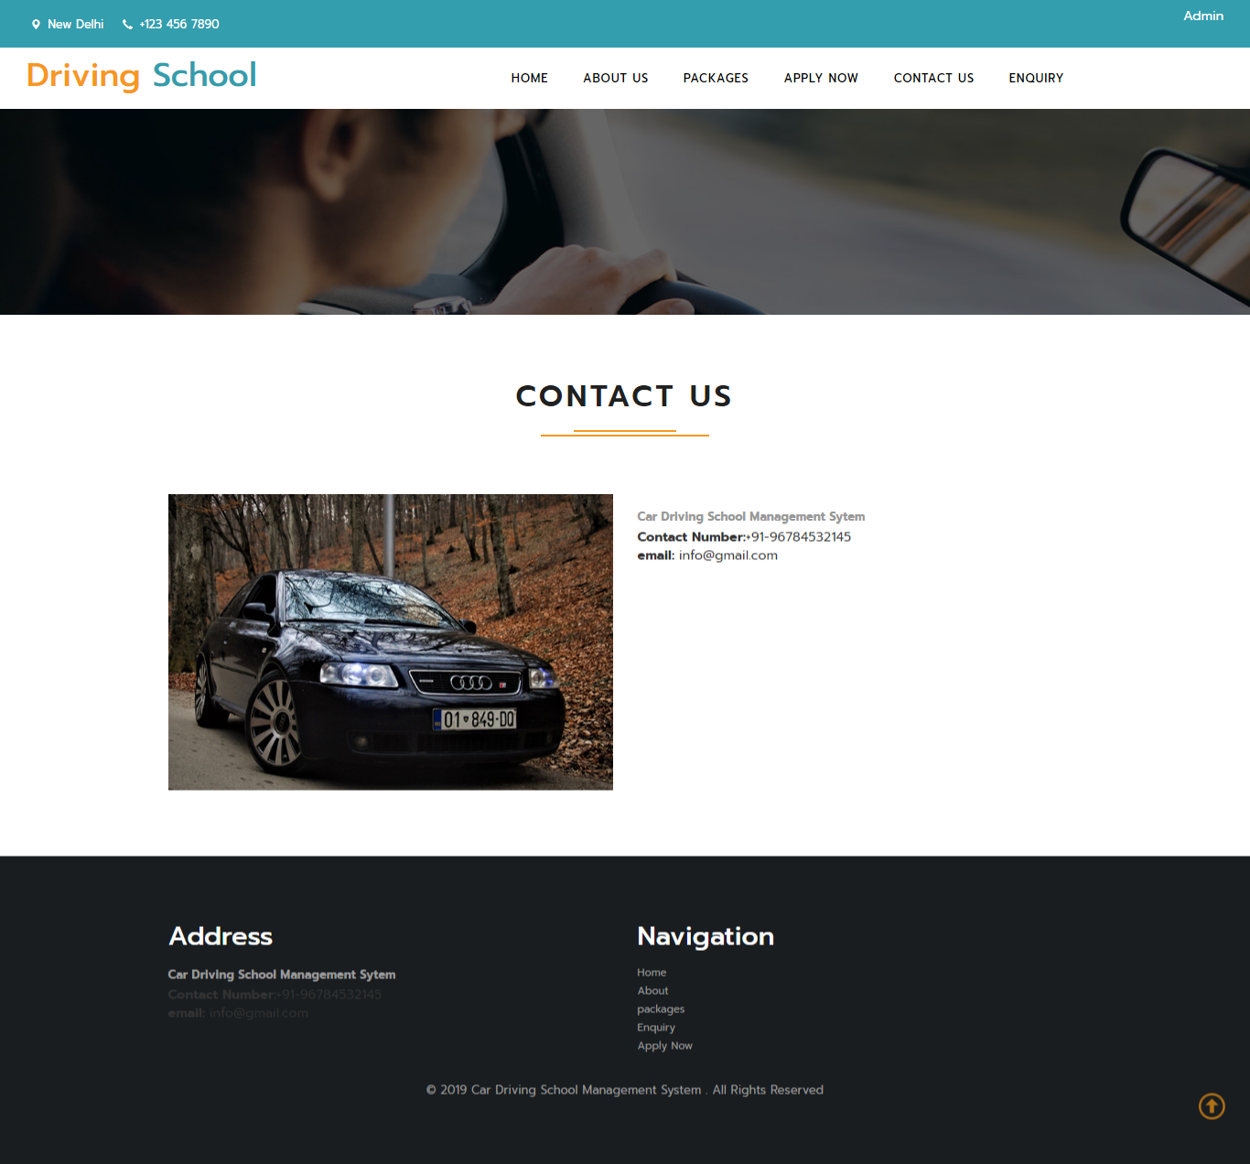

**Enquiry**

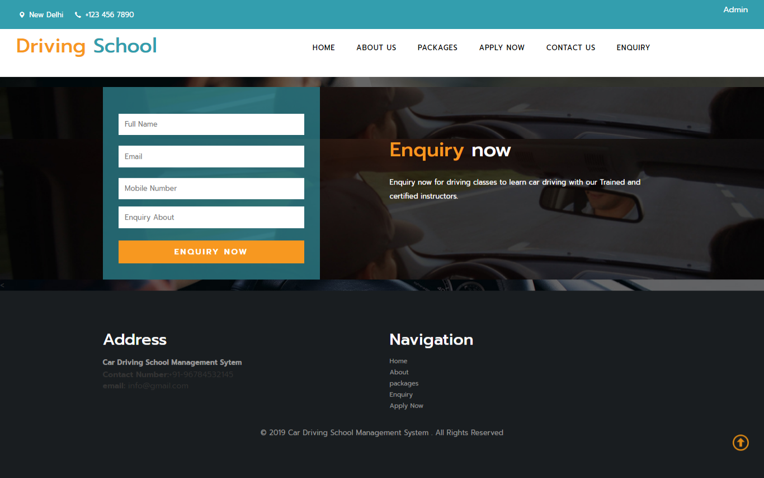

**CONCLUSION**

The package was designed in such a way that future modifications can be done easily. The following conclusion can be deduced from the development of the project.

* Automation of the entire system improves the efficiency.
* It provides a friendly graphical user interface which proves to be better when compared to the existing system.
* It provides a friendly graphical user interface which proves to be better when compared to the existing system.
* It gives appropriate access to the authorized users depending on their permissions.
* It effectively overcomes the delay in communications.
* Updating of information becomes so easier.
* System security, data security and reliability are the striking features.
* The System has adequate scope for modification in future if it is necessary.

**BIBILIOGRAPHY**

* www.w3schools.com
* ***php****.net*
* *en.wikipedia.org/wiki/****PHP***
* www.hotscripts.com/category/**php**/
* www.**apache**.org
* www.**mysql**.com/click.php?e=35050